SNC1D Exam Review
These are the formula’s that you will be given:
Resistors in Series:
R_{T} = R₁ + R₂ + …

Chemistry Review
- Particle Theory
Particle Theory of matter describes the different behaviors of solids, liquids and gases.
- All matter is made up of tiny particles that have empty space between them.
- Different substances are made of different kinds of particles.
- Particles are in constant, random motion.
- The particles of a substance move faster as the temperature increases.
- Particles attract each other.
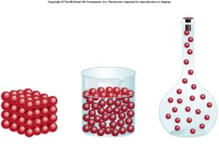

- Physical and Chemical Properties
- Physical property is a characteristic that can be determined without changing the composition of that substance.
    - State – solid, liquid, gas, plasma
    - Colour
    - Density, viscosity
    - Hardness, brittleness
    - Taste, odour, texture, lustre, clarity
    - Melting and boiling points
    - Ductility (bendable) and malleability (able to be hammered)
- Chemical property is a property of a substance to produce one or more new substances.
- heat of combustion
- reactivity
- PH
- flammability
- Four Signs of a Chemical Change
- A change of Colour (new substance has formed and it has a different colour)
- Bubbles (not caused by heating, shows the new substance is in the form of a gas)
- Energy is released or absorbed (heat, light, freezing)
- A precipitate was formed (a new solid is produced that does not dissolve in the mixture)
    - A change of odour (in text)

- Physical and Chemical Change
- A physical change when there is no new product formed. The particles of the starting substance are not changed.

  - Ice melting to form water
  - Dew drops condensing on a leaf at dawn
  - A sculpture being created by carving a piece of wood
  - Water freezing in winter into ice
  - A piece of glass breaking to pieces
  - Copper metal being drawn into wires
  - Blowing up a balloon
  - Ice cream melting to a liquid
  - Snowman melting in the Sun
  - Heating up a metal and beating it into a different shape

- In a chemical change, the substance changes identity into something else.

- Burning a log of wood
- Heating popcorn
- Baking a cake or pancakes
- Frying or boiling and egg
- Rotting of fruit
- Rusting nail
- Roasting a marshmallow
- Digestion of food
- Moldy cheese
- Souring milk
- Curdling of milk

- Mixture and Pure
- Matter is made up of many different types of particles.
- Pure matter is made up of only one type of particle.
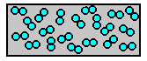
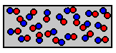
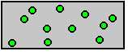

Element Molecule Compound
Is two or more atoms of the same or different elements in a chemically joined unit.
Is a pure substance that cannot be broken down into simpler chemical substances.
Is a pure substance composed of two or more different elements chemically joined.

- Mixture is a substance that is made up of at least two types of particles.
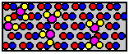
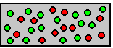

    - A mechanical mixture is when you can distinguish between the different types of matter.
    - A solution is a uniform mixture of two or more substances.
    - An alloy is a solution of two or more metals.

- Homogeneous and Heterogeneous
- A homogeneous mixture has the same uniform appearance and composition throughout. Many homogeneous mixtures are commonly referred to as solutions.
  - Salt water, rubbing alcohol mixed with water, vinegar
- A heterogeneous mixture consists of visibly different substances or phases.
  - Soil, blood, sand and salt mixed, vinegar and oil mixed
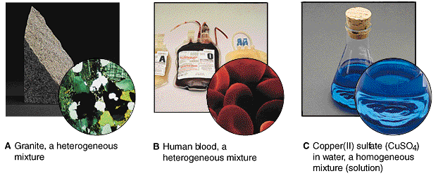

- Solution and Suspension
- A solution is a mixture of two or more substances in a single phase.
  - The substance in the smallest amount and the one that dissolves or disperses is called the SOLUTE.
  - The substance in the larger amount is called the SOLVENT.
  - In most common instances water is the solvent.
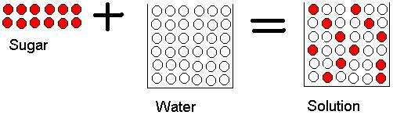
- A suspension is a heterogeneous mixture of larger particles. These particles are visible and will settle out on standing.
  - fine sand or silt in water, tomato juice.
- A colloid has intermediate particle size between a solution and a suspension. Colloid particles may be seen in a beam of light.
  - Milk, fog, and jello
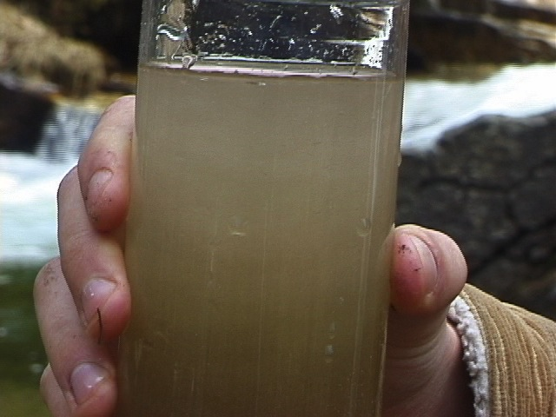
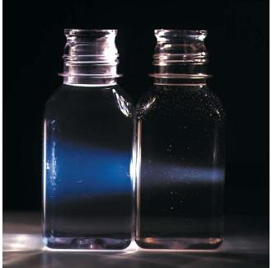

- Quantitative and Qualitative
- A qualitative property of a substance is not measured, nor does it have numerical value. (colour, odour, texture, taste, feel, smell)
- A quantitative property of a substance is measured and has a numerical value. (temperature, height, mass)

- Three Gas Tests
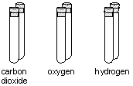
- Test tube with CO₂ will put out a burning flame
- Test tube with O₂ will light up a match that was recently blown out
- Test tube with H₂ will make a popping sound when the match is inserted

- Periodic Table
- Families
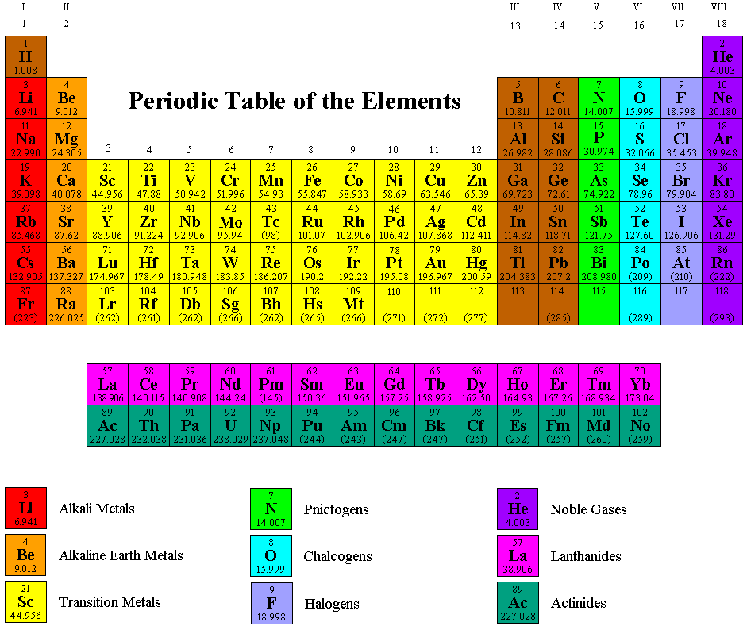
- Metals, non-metals, and Metalloids
- Metals are elements that are located on the left hand side. They are usually lustrous, malleable, and ductile. They conduct electricity and heat well.
- Non-metals are elements found on the right hand side and are usually a gas or liquid. They do not conduct heat or electricity well.
- Metalloids have properties of both metals and non-metals. They are found along the zig zag line.
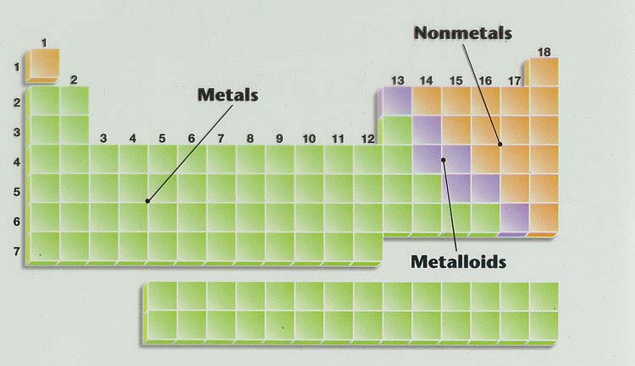
- Periods and Groups
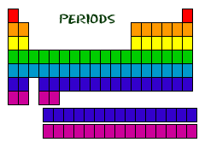
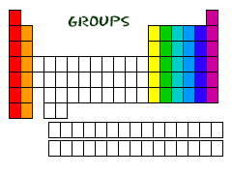

- Properties of Families on the periodic table
- Alkali Metals
Low densities, float on water, combine readily with other elements (think of the metals and water video!)
- Alkaline Earth Metals
Shiny and silvery, not as soft as group 1, burn bright colours
- Halogens
Mostly gases (Br is a liquid and At is a solid), very reactive, poisonous
- Noble Gases
Stable, unreactive, colourless, odourless, tasteless, glow brightly, mostly non-toxic

- Name and Symbol of elements 1 – 20
- Use your Periodic Table to know the names and symbols of the first 20 elements.

- How is the periodic table organized
- See pictures above

- Models of the Atom
- Indivisible Particle - Greeks

- Small Dense Sphere – John Dalton
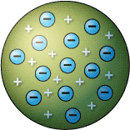

- Plum Pudding Model – J.J. Thomson
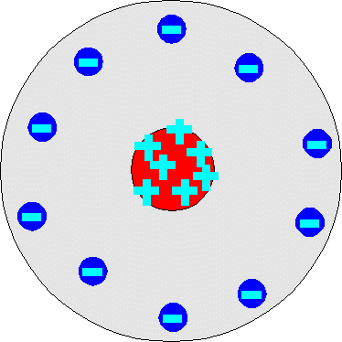
- Gold Foil Experiment and the new Atom – Rutherford

- Electron Orbits – Bohr
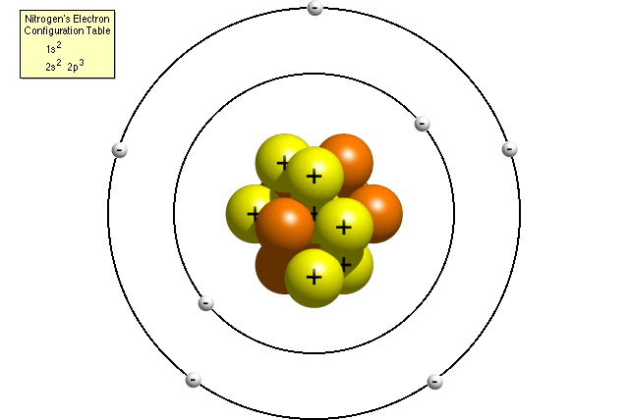

- Elements, Compounds and Molecules
- Element is a pure substance made of one type of atom
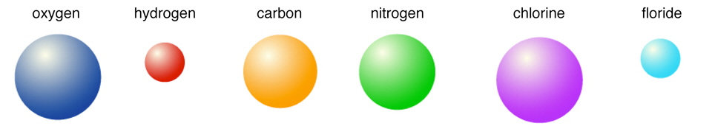
- Compounds are pure substance made of two or more types of atoms that are chemically joined
- Molecules are two or more atoms of the same or different elements, chemically joined

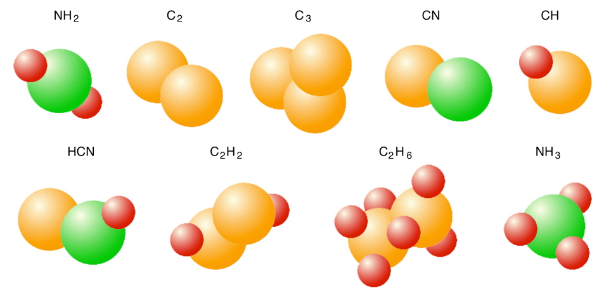

- Atomic Number, Atomic Notation, Protons, Electrons, Neutrons
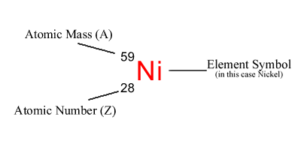
- Atomic number is the number of protons in an atom’s nucleus
- Atomic Mass is the average mass of an atom

- Mass Number is the number of protons plus the number of neutrons in an atoms’ nucleus
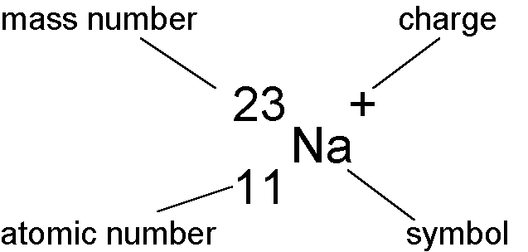
- An ion is a particle with a positive or negative charge.
- Charge is equal to protons minus electrons.

- Ion and Isotope
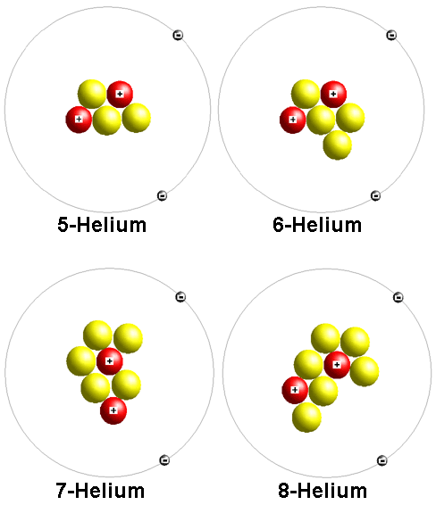
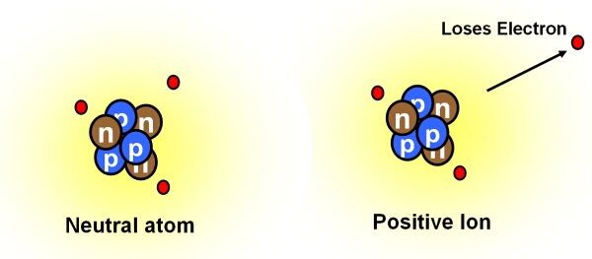
- Isotopes are atoms with the same number of protons, but different number of neutrons

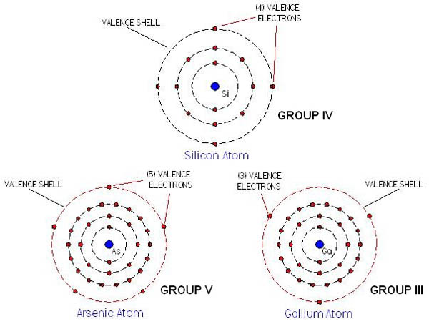
- Valence Electrons
- Outer shell electrons used for bonding
- Group 1 has 1 valence electron
- Group 2 has 2 valence electrons
- Group 3 has 3 valence electrons

- Rutherford-Bohr diagram
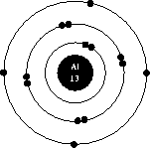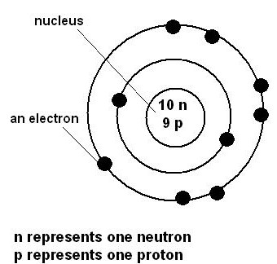

Physics
- What is the difference between and insulator and a conductor?
- Insulators are materials that do not allow charges to move freely on or through the object.

- Amber
- Cotton
- Ebonite
- Fur
- Glass
- Paper
- Plastic
- Porcelain
- Rubber
- Silk
- Sulfur
- Pure water
- Wood
- Wool
- Materials that allow charges to move freely on or through the objects are called conductors.
- Aluminum, copper, gold, iron, magnesium, mercury, nickel, platinum, silver, tungsten

- What is the law of attraction?
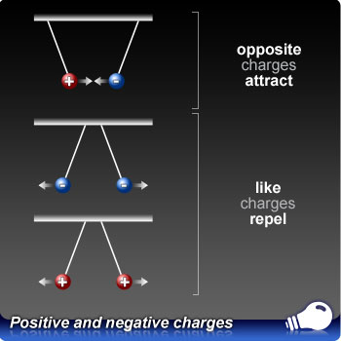

- What does the term grounding mean? (symbol)
- Grounding a conductor means to connect it, through some conducting material, directly to the ground (earth).

- Earth is not an excellent conductor, but because it is so massive, it can accept or give up electrons without any significant change to its overall charge.

- How does lightning occur?
- During a storm, particles move around in the clouds. This separates the charges, resulting in positive and negative parts of a cloud.
- If a negatively charged part of the cloud passes near a part of the earth it will become charged by induction.
- Electrons jump from the cloud to the earth. As the electrons jump through the air, they produce intense light and heat. The light you see as a lightning bolt. The thunder you hear is the expansion of air due to the build up of heat.

- List three applications of static electricity
- Air filters, Automotive paints, Spray painting, photocopy machines, laser and LED printers

- List three ways to charge an object. Use an electroscope to illustrate the two ways.
- Friction is when two substances are rubbed together, one of them will lose electrons to the other. The object that has lost electrons will become positively charged. The object that has gained electrons will become negatively charged.
- Conduction is when direct contact of objects is necessary. Electrons flow from one object to another.
- Induction is when a neutral object comes close to a charged object to become negatively charged. No contact is necessary. This is a rearrangement of charges.

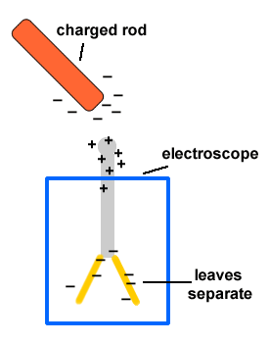

- What are three sources of electrical energy?
- Electric Cell is a portable device that converts chemical energy into electrical energy. It consists of two electrodes and a conducting solution (electrolyte). The term battery refers to two or more electric cells in combination.
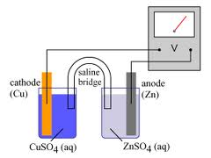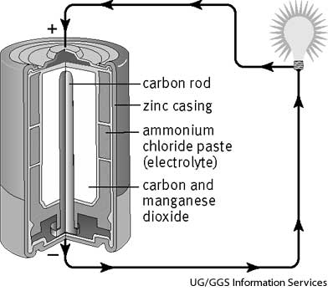
  - Primary
    - Electric cell that cannot be recharged
  - Secondary
    - Electric cells that can be recharged
- Fuel Cell is a special kind of electric cell through which a continuous supply of chemicals is pumped as the cell operates. Fuel cells can operate longer that conventional electric cells.
- An electrical generator obtains energy from a non-electrical source and converts it to electrical energy. The external source spins the turbine, which then spins the generator (coil of wire inside a magnet) producing electrical energy.

- What are three environmental concerns associated with the production of electrical energy

- What are three alternative energy sources?
- Hydro-electric Generation
- Tidal Generation
- Thermal Generation
- Wind Generation
- Energy from Light

- What is the difference between a renewable and a non-renewable energy source?
- Renewable energy is energy which is generated from natural sources (sun, wind, rain, tides) and can be generated again and again as and when required. They are readily available and are clean sources of energy
- Non-renewable energy is energy taken from the earth’s sources that are limited in quantity. Non-renewable sources are not environmental friendly and can have serious affect on our health. Non-renewable sources exist in the form of fossil fuels, natural gas, oil and coal.

- What is power? (expression and units)
- Electrical power is the rate at which electrical energy is produced or used in a given time.
- The unit is a Watt (Joule per second)
- Power is equal to Energy divided by time (P = E/t)

- Why is nothing 100% efficient?
- Efficiency is a measure of how much useful energy an electrical device produces compared with the amount of energy that it was supplied.
- Percent efficiency = Energy out x 100%
Energy in
- A light bulb uses 100J of energy and produces 25 J of light. What is the efficiency?

Percent efficiency = 35 / 100 x 100%
0.35 x 100%
35%

- What is current? (expression, units, how is it measured?)
- Electric current is the amount of electrons (charge) that passes a point in a conducting wire per second.
- Current is measured by an Ammeter.
- The unit is an Ampere (Amp)
- I = Q/t
- What is potential difference? (expression, units, how is it measured?)
- Potential difference is the difference in electric potential per charge at two different points in the circuit.
- Another word for potential difference is voltage
- Potential difference is measured in volts and is measured by a voltmeter.
- V = E/Q

- What is resistance? (expression, units, how was in measured in a lab?)
- Resistance is the ability of the material to oppose the flow of electrons.
- Resistance is measured in Ohms (Ω)
- In a lab, a circuit is set up. The ammeter measures the amps and the voltmeter measure the volts. And then we calculate resistance (V/I).
- We also graphed volts and amps and calculated the slope (resistance)
- What four factors affect resistance?
- Type of material – some materials are good for letting electrons flow, while others are not (Copper, silver, gold are good)
- Cross Section – A thick wire will let electrons flow through more easily than a this wire
- Length – a longer wire has more resistance because the electrons have further to travel.
- Temperature – resistance will increase with temperature
- What is the difference between a series and a parallel circuit?
- A series circuit has only one path for current to flow.
- In a parallel circuit, the different parts of the electric circuit are on separate branches, which gives electrons several options when traveling around a circuit.

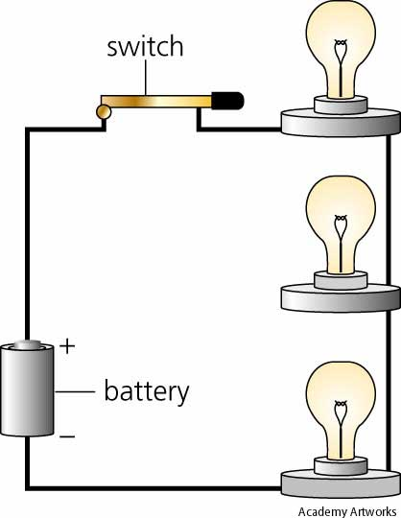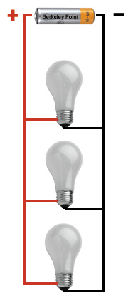

- How do current, resistance, and potential difference behave in a series circuit? And in a parallel circuit?

- Resistance is voltage divided by current (R = V/I)
- In a series circuit the current stays the same throughout the circuit. The voltage is additive. Resistance is calculated as R_{T} = R₁ + R₂ + R₃…
- In a parallel circuit, the current is additive and the voltage stays the same. Resistance is calculated and the reciprocal R_{T} = reciprocal R₁ …

